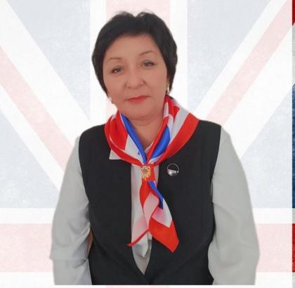
АЙДЫНБЕКОВА Динара Тураровна,
№4 Балжан Бөлтірікова атындағы мектеп-лицейінің ағылшын тілі пәні мұғалімі.
Жамбыл облысы, Қордай ауданы

HUMAN BEINGS

Learning objectives |  | 5.3.1 provide basic information about themselves and others at sentence level on an increasing range of general topics;  5.5.8 Spell most high-frequency words accurately for a limited range of general topics;  5.6.7.1 use simple tense forms of common verbs to express what has happened [indefinite time] on a limited range of familiar general and curricular topics;  5.1.6 organize and present information clearly to others.
Lesson objectives |  | to pronounce and name parts of the body  to talk about function of parts of body  to practice the use of present simple  respond to the questions correctly
Value links |  | Appreciate the importance of taking care of their bodies
Plan
Planned timings | Planned activities |  | Learners’ activities | Evaluation | Resources
Beginning  5 min | 1.GREETING .  T: Good morning, students! I am glad to see you. How are you today? I hope you are well.  2. Warm-up  a)Telling different proverbs  b) Game ‘’snowballs’’  3. Vocabulary work  Task:1 Match the pictures with their names and say.  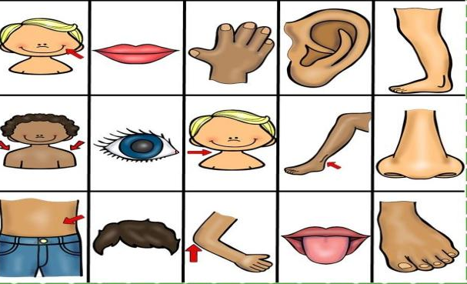 |  | Learners tell the proverbs and name adjectives  Learners match the pictures with their names and say  Learners do this task with help of AI | Individual avaluation | Pictures  Using the phones  https://learningapps.org/view19365833
Middle  25 min | 4.Physical pause  Students sing a song  5. Group work. Vocabulary work  Task:2. Fill in the gap, put necessary verbs with group  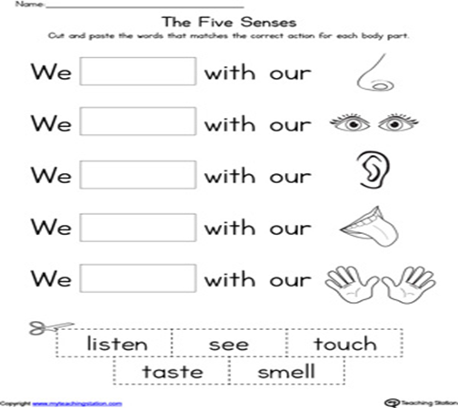  6.Reading the text.  Text: Human Beings  Human beings are special living things. We can think, speak, learn, and solve problems. We live in families and groups, and we help each other. Humans are different from animals because we can build houses, create art, and use tools.  Our body is made up of many parts that work together. The brain controls our thoughts and actions. The heart pumps blood. The lungs help us breathe. Bones and muscles support our body and help us move.  Human beings need basic things to live: air, water, food, clothes, and shelter. We also need love, care, and education to grow and live happily.  Tasks:  1. Fill in the Blanks:  a) The __ controls our thinking.  b) Humans are different from animals because we can __ and __.  c) We need food, water, and __ to live.  2. True or False:  a) The lungs help us see.  b) The heart pumps blood in our body.  c) Humans need love and care to live happily.  4. Match the Following:  - Brain →  - Heart →  - Lungs →  - Muscles →  (Options: Breathe, Think, Move, Pump blood)  7.Speaking  A)T-r puts the questions  1 What does brain do?  2 What does heart do?  3 What does lungs do?  4What does muscles do?  B) students describe different people |  | Learners  fill in the gap, put necessary verbs with group  Learners  Read the text and do the tasks  Learners fill in the blanks with necessary words  Learners choose the right variant true / false  Learners match the following:  Learners answer the questions  Learners do this task with help of AI | Verbal evaluation  Mutual avaluation  Self-assessment  Formative assessment | Flashcards, active board  Flashcards, active board  blackboard  Worksheets  Slides  PPT
End  5 min | Conclusion.  T-r puts the questions  Reflection  What have you learnt today?  What was easy for you?  What was hard for you?  How do you feel during the lesson? |  | Learners answer the questions and fill the card | 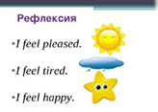 | Reflection cards

